Name: Harsh Mohan

Email Address: [harshmohan009@gmail.com](mailto:harshmohan009@gmail.com)

Mobile number: 8076432235

Complete Analysis Of accountsjunction.com

1. Trust of SSL certification

A website being secure by https is being trusted by the people and get a good search preference by the people.

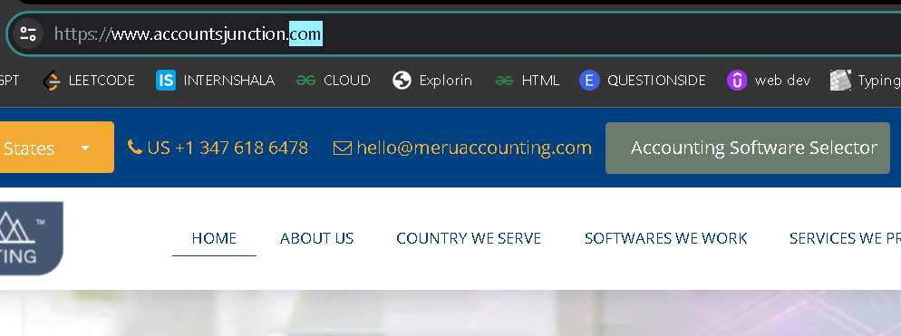

1. The header of any website contains main tabs only not information this leads to some irregularities, request to remove the phone number section from top. We can add this in footer.



1. By clicking on the company logo the site is getting a soft refresh without erasing any data this feature will facilitate the customer and a lead fort eh company.
2. All the tabs must be highlighted by some bold background as it is slightly not visible.
3. Facing problems while scrolling down from cursor as the major background image starts shaking it needs to be static not dynamic or resolve any other issue if there is.
4. It looks annoying when I am cancelling the contact form and it rapidly comes again.
5. The contact form is not in it’s format and all the fields come in a straight vertical fields of remote buttons but mobile number field is aside of name which is not a good format.

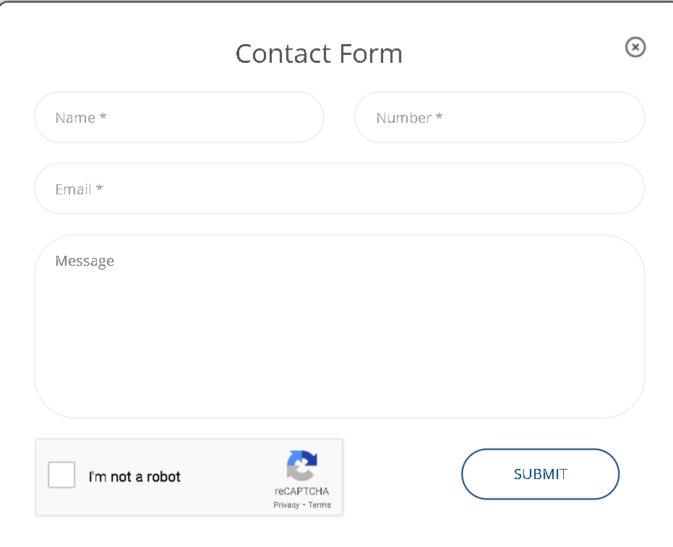

1. The automatic chat model is considered to be one of the best feature but it’s repetitive nature may irritate the user. 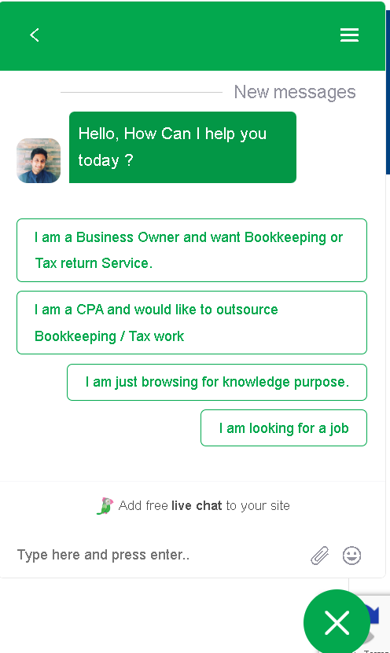

HOME TAB FEATURES

1. The picture slide consists of three images but instead of being cyclic it acts as start to end. It must be in continues manner.
2. The increment in data slab is working properly.
3. The data slab consists of images in 2 section but no image in last two this decrease the overall impression of the site at first look.



1. Spacing is required between two different services.

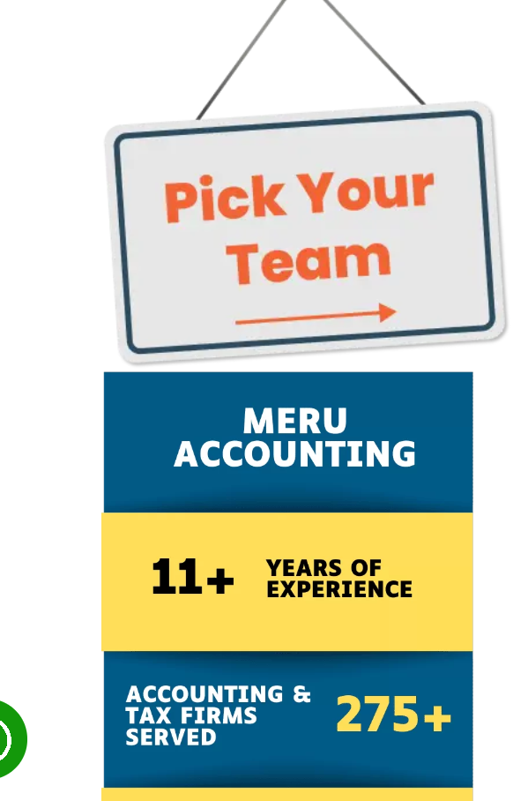

1. No video or image for support of Audit support facility

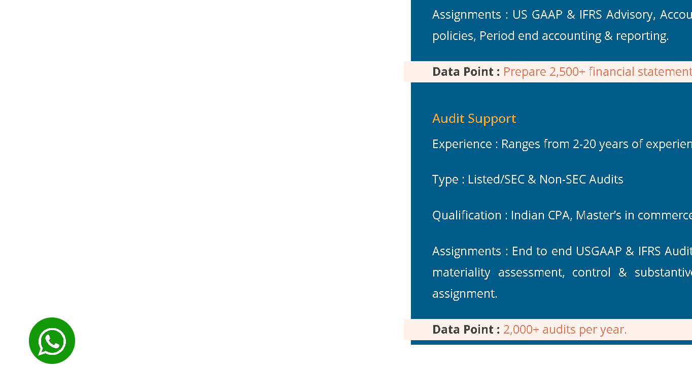

1. From above photo the WhatsApp help must be in the footer tab but it floats in the whole site.
2. Software expertise needs some more animation to sow all the companies that take your help with their experience.

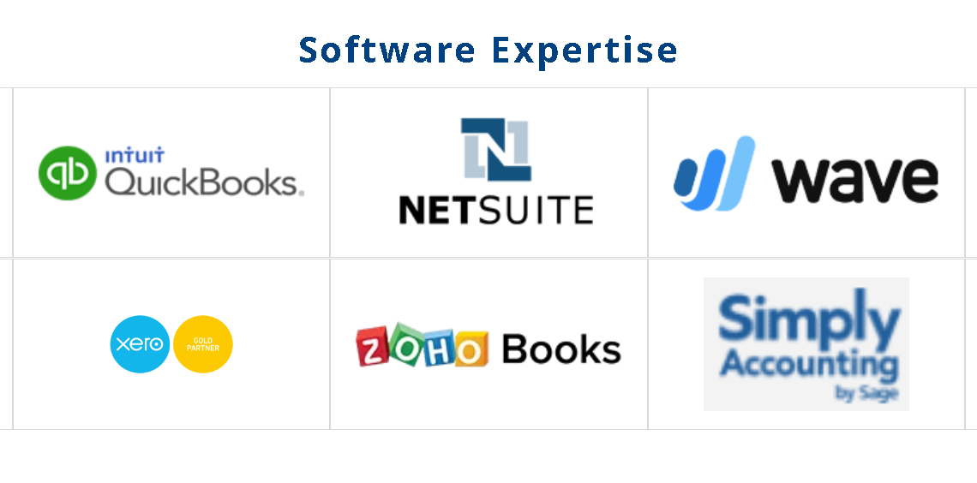

1. Important: Please make the site title fixed



1. Bookkeeping CFO services must have specified links to redirect to the services area.
2. Font error found in the CFO region.

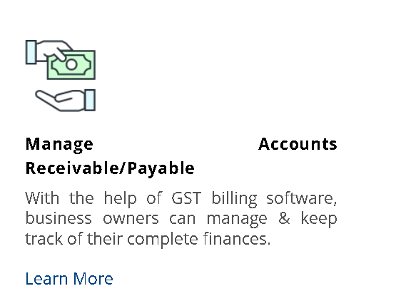

1. Mission and values points must be in list format.

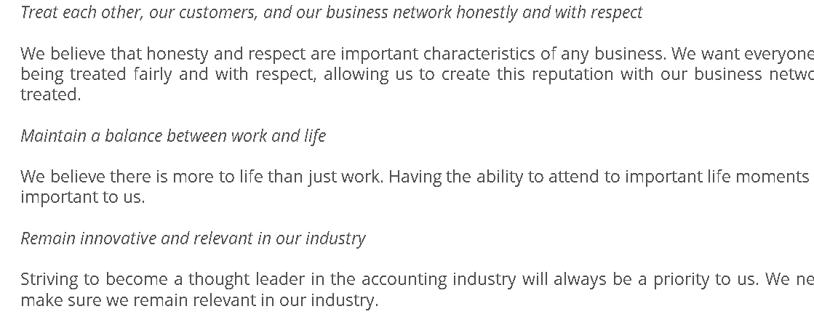

1. What is for section must be in a specified container.
2. Certificates section must have a dedicated tab for showcase.
3. The dynamic movement of logo in outsource Accounting Services gives a good look.
4. If customer approves then we can their photo also.

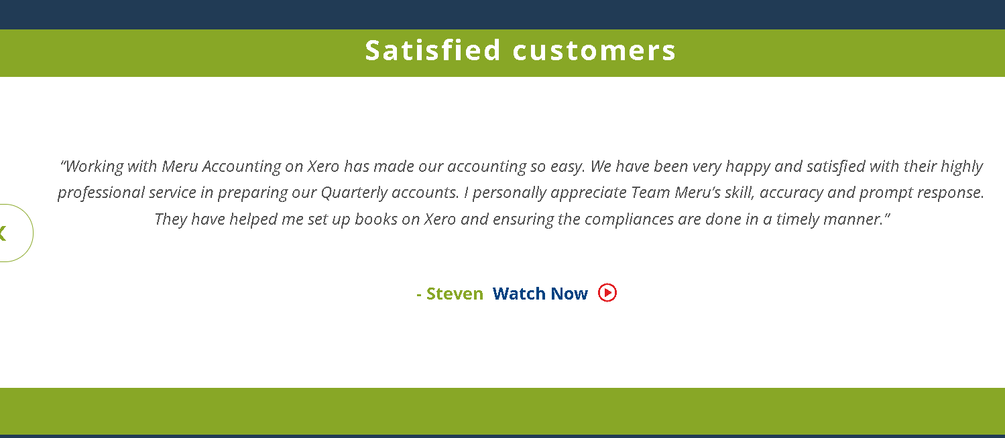

1. Introductory call needs a good design.

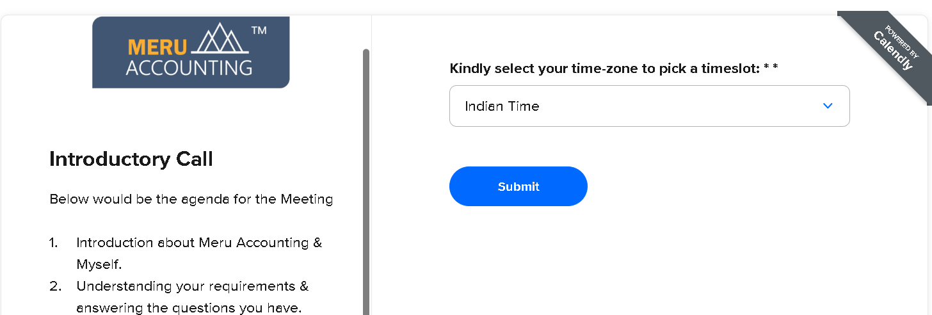

1. At last HOME TAB is too long that a user can get distracted and may not get appropriate services so it highly needed to be shortened.

ABOUT US TAB

1. Facing scrolling problem all throughout the web pages.
2. Keep the history some shorten as it looks like a story instead of motivational achievement
3. In software expertise section links are not working.



COUNTRY SERVICE TAB

1. Only United Kingdom section is attached with their flag request to add their respective flags in each section.

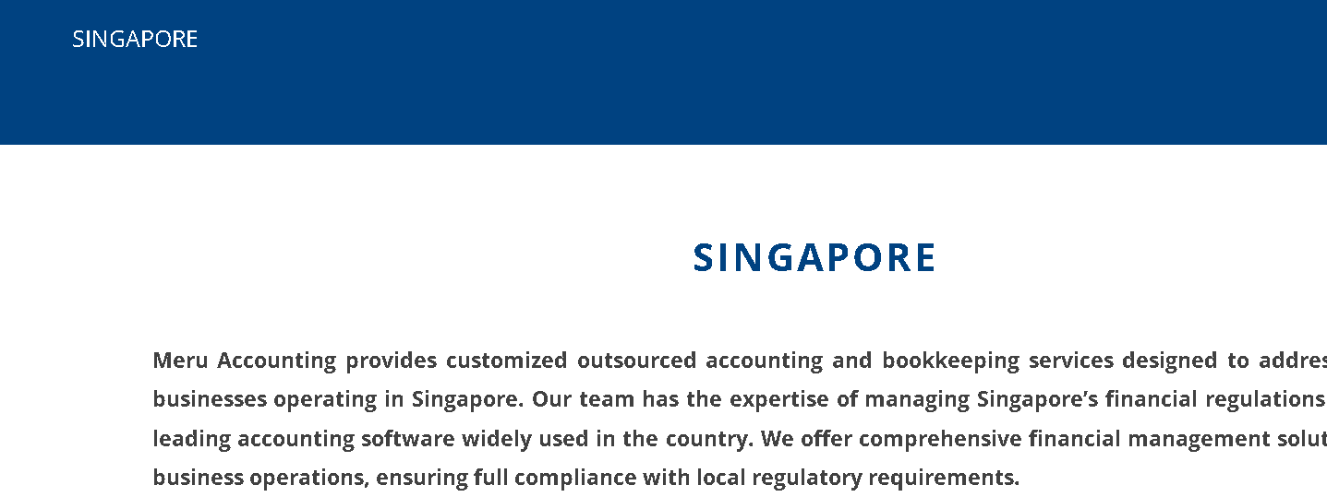



SOFTWARE WE WORK

1. This tab is not working

SERVICES WE PROVIDE TAB

1. All four categories are linked properly.
2. But the schedule call option is getting delayed.

Industry serving area

1. Links and styling are highly recommended.
2. Instead of paragraph bullet points will create good impression.

Join us tab

1. All information is available there but no active link to join or apply in the company.